**Standard six English language notes**

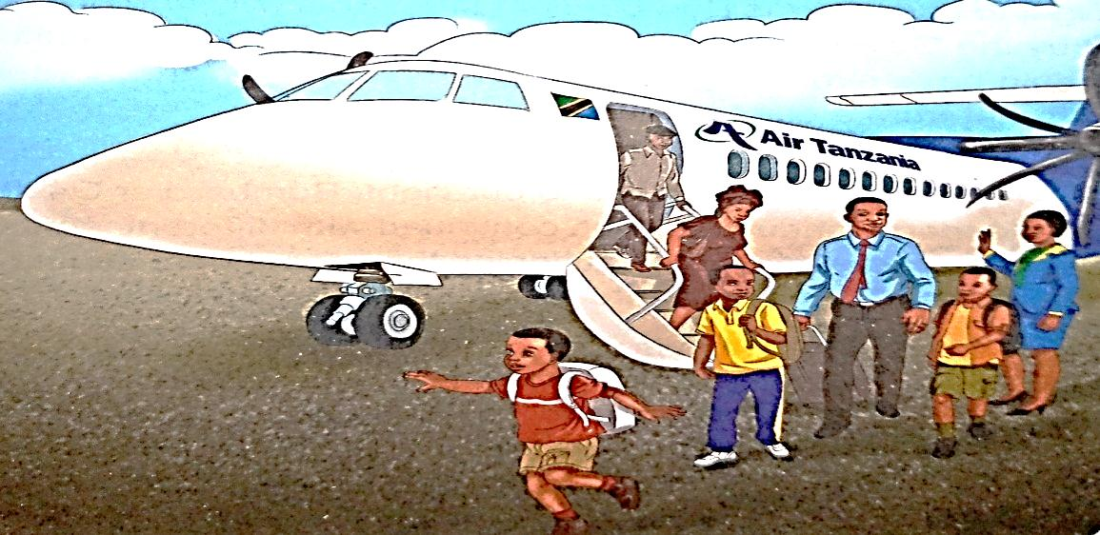

**KWA MUENDELEZO WA NOTES HIZI TUONE INBOX**

**0747249620**

1.0 COMPREHENDING ORAL AND WRITTEN INFORMATION

* 1. **Listening and comprehending information presented orally**

**a). Listening to recorded material about common issues and answer questions orally.**

**Speaking practice**

a) In pairs, read and act out the following dialogue.

Pata: Hi Tizo, how do you feel?

Tizo : Hi Pata, I am feeling much better, if I hadn’t gone to the hospital, I wouldn’t have improved this much.

Pata: What did the doctor say?

Tizo: He said that I had a bacterial infection which, I think, I got either at school or at home.

Pata: I hope you get well soon. Take care because our surroundings are full of bacteria.

Tizo: That’s true, but if our surroundings are clean, we will all be safe from diseases.

Pata: Certainly! I agree with you. We should be serious about cleanliness.

Tizo: Right. If we are serious, we will make sure we cut the grass and remove all dirt.

Tizo: Absolutely! We also have to clean our houses.

Pata: Very true. Unless we study these practices, we will always be falling sick.

Tizo: It has been nice talking to you.

Pata: It has been nice talking to you too. Now, let me go. You need to get some rest. Goodbye and take care.

Tizo: Bye, see you soon.

b). Re-read the dialogue and answer the following questions.

1. Why did Tizo go to hospital
2. Why did he fall sick?
3. What should we do if we want to avoid diseases?
4. What will happen if we do not go to hospital early when we fall sick?
5. Experience shows that some people do not go to hospital when they fall sick. Give four reasons as to why they do not do so.

c). Say the following tongue twister aloud several times

Clean clams crammed in clean cans.

**Reading practices**

a) Read the passage below and answer the questions that follow.

**Mtakuja village cleaning day**

It was Saturday, early in the morning when everybody was supposed to take part in cleaning the village surroundings. Men, women and children gathered at the village office ready for work. They were carrying different cleaning tools including machetes, scythes, hoes, long and short brooms, buckets, masks and gloves. Everybody was supposed to participate, unless he/she was sick.

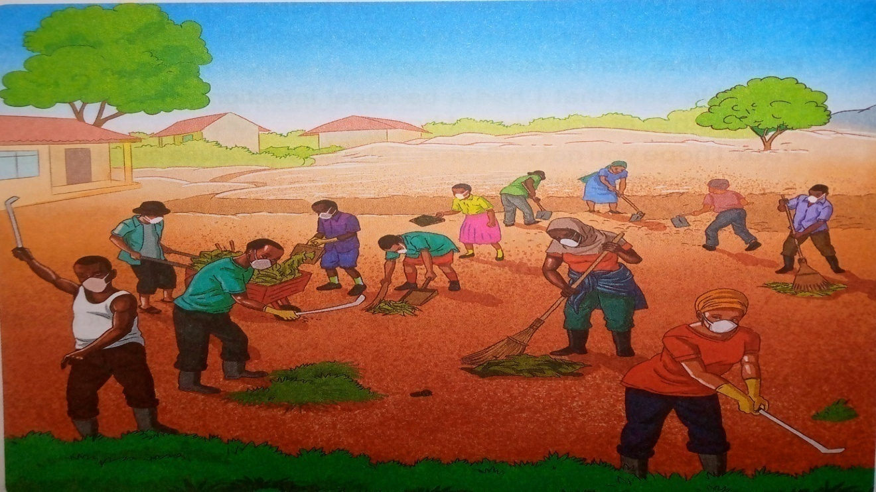

MrMtumzuri, the village chairperson, was also there. He addressed the villagers on the issue of cleanliness. Firstly, he said that he was delighted to see that the villagers had responded positively to national campaign to clean their surroundings. Secondly, he instead on the importance of keeping the village surroundingsclean. Thirdly, he asked everybody to consider himself or herself as part of the team. He concluded, “If we all work together as a team, the task will be easy and effective.” He then welcomed MsZawadiMtukwao, a health officer, who was also impressed by the people’s response to the task of cleaning the surroundings.

One of the things that MsZawadi talked about was how to prevent malaria. She said, “We must get rid of pools of stagnant water and old containers such as bottles and cans. If we do this, it will stop mosquitoes that cause malaria from breeding. Make sure that you have a pit at home to throw your rubbish in, and special dustbins for tins and bottles. This will help us keep our surroundings clean and attractive.” The health officer also encouraged people to use toilets. The villagers received the advice.

The village chairperson thanked the health officer for her speech. Then, he reminded the villagers about the village rule that requires everybody to participate in cleaning the village surroundings. He said, “If you don’t participate you will have to pay a fine. Such fines will be used to buy more cleaning tools.”

People listened calmly and attentively. After the speech, the villagers were divided into small groups. Some groups were assigned the task of clearing the bushes around the trees and along the paths. Others were asked to collect plastic bags and bottles and cut the long grass around the village. Some strong people volunteered to dig trenches to allow rain water to flow freely. People sang happily while they were working. It took them about four hours to finish the task, but they did not look tired. They also did not complain because they knew that, if they had not done the job thoroughly, they would not have beautiful and health surroundings.

Questions

1. What day of the week did the villagers meet to clean the village surroundings?
2. Who participated in the cleaning task?
3. What tools did they use to clean their surrounding?
4. What two things did the village chairperson talk about?
5. What three things did the health officer talk to the villagers about?

**Vocabulary practice**

a) Match the words in column X with their meanings in column Y

|  |  |  |  |  |
| --- | --- | --- | --- | --- |
| No | Column X | Answers | No | Column Y |
|  | **Words** |  |  | **Their meanings** |
| 1 | Surroundings |  | i | not moving |
| 2 | Prevent |  | ii | make someone pay money as a punishment |
| 3 | Machetes |  | iii | long, narrow holes dug in the ground |
| 4 | Hoes |  | iv | take part in an activity or event |
| 5 | Team |  | v | an area that has not been cleared |
| 6 | Stagnant |  | vi | large knives used as weapons or tools |
| 7 | Fine |  | vii | areas around |
| 8 | Participate |  | viii | protect from |
| 9 | Trenches |  | ix | tools used for cultivating or clearing the ground |
| 10 | Bush |  | x | a group of people working together |

b). Select the words from the box below to complete the sentences that follow

|  |  |  |  |  |
| --- | --- | --- | --- | --- |
| harmful | dirt | Throwing | Poisoned | Neat |
| rubbish | dust | dustbins | Disposable | Containment |

1. We have a lot of ……….. at our school.
2. Anna wipes the ……….. off her desk.
3. People throw ……….. everywhere and make the surroundings dirty.
4. Don’t drink …………. Water.
5. My little brother uses………… nappies.
6. They are ……… the rubbish in the pit.
7. Living in dirty surroundings is …………………

**Language practice**

Expressing Condition

Conditional Sentences

A condition

Is something that has to be fulfilled first before something else could happen.

Example

If you don’t pay school fees, you will not sit for the exams.

That is to say: You have to pay fees first so that you can be allowed to sit for exams.

* If you study hard, you will pass your exams.
* If Zainabu sleeps early, she will wake up early.
* If Hassan drives a car, we will arrive on time.
* If, unless or in case are the common words used in conditional sentences.

**2. Types of conditional sentences**

There are three types of conditional sentences.

**i). Conditional sentences (type 1)**

This refers to the future. An action in the future will only happen if a certain condition is fulfilled by that time.

If + simple present + will ( future tense)

Example

* If I call him, he will come.
* If you throw a stone in the water, it will sink.
* If you heat butter, it will melt.

**Exercises**

a). Make 10 Conditional sentences type 1

b). Complete the conditional sentences type 1 by changing the verbs provided in the brackets into the correct form

1. If you_____ (send) this letter now, she_______ (receive) it tomorrow.
2. If I _______(do) this test, I ________(improve) my English.
3. If I ________(find) your ring, I ________(give) it back to you.
4. Salma ________(go) shopping if she_______ (have) time in the afternoon.
5. Simon_______(go) to London next week if he ________(get) an air ticket.
6. If I ______(go) out tonight, ______(go) to the cinema.
7. If you _______(get) back late, I ________(be) angry.
8. I ________(come)early, if you______(ant).
9. They _________(go) to the party, if they_______(be) invited.
10. She _________(stay) in London, if she ________(get) a job.
11. He ________(not/ get) a better job, if he _____ (not/pass) that exam.
12. I _______(buy) a new dress, if I ___________(have) enough money.
13. She __________ (cook) dinner, if you________(go) to the supermarket.
14. We _______(be) late if we __________(not/hurry).
15. She _________ (take) a taxi, if it ________(rain).

**ii). Conditional sentences (type 2)**

This refers to the situation whereby an action could happen if the present situation was different. In this case it is possible but very unlikely that the condition will be fulfilled.

If + simple past + would + infinitive verb

Examples

* If I had a car, I would take you to him.
* If I tried hard, I would pass the test.

**Exercises.**

a). Make 10 Conditional sentences type 2

**KWA MIENDELEZO TUONE INBOX**

**0747249620**